Toilet Training

Dogs learn through constant repeat of commands. Each command will convey a different request, asked by the owner. These are called “Keywords” in other words, they trigger the desired response. Consistency of words is very important. Select a word or two that you are to use for toilet training i.e. “be quick” “get done” tinkles etc.

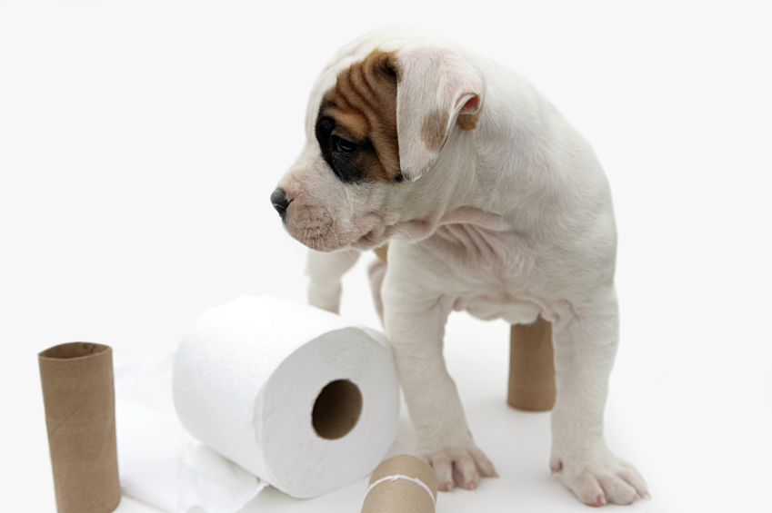
It doesn’t matter what the words are, but each family member should use the same words in order that the pup understands. Sometimes people will simply say “oh! Good boy” when the puppy goes to pee. This is not enough, as you will probably and hopefully say “good boy” a hundred times a day.

You need a command to go along with “good boy” Every time your puppy goes to his toilet, put in your command. You are teaching him a command, and as you repeat it each time he wees, he will start to realize what the command means. It means you want me to wee. Very quickly he will catch on, then when you take him outside you introduce your Keyword over and over until he obliges.

Puppies can be very frustrating when it comes to outdoor toilet training because there is a whole new world to be explored out there, and the last thing on his mind may be going to the toilet. After all he can do that when he goes back indoors. Take him out very regularly, after every feed or drink. If possible give him a drink prior to going out, to encourage him to want to go. Be patient with him.

Dogs are creatures of habit, and it is possible to train them to specific places. Always clean up immediately after your dog. The only cleaning solution that removes the smell of the mess to your dog is biological wash powder. So clean all areas that have been used as a toilet with a mix of water and biological washing powder. Routinely mop your kitchen/utility rooms with this solution and then mop over with disinfectant is the risk of germs is a problem for you. An adult dog may clean up after a puppy, after all a bitch will clean her puppies until they are weaned. By cleaning up immediately you have a much better chance of eliminating this trait.

Consider using a crate during the house training process, dog are naturally clean animals and they will not toilet in the area they consider to be their bed area. We need to teach them that the house is their bed when initially they think it is just their dog bed, so usually get off the bed and move elsewhere in the room, toilet and then go back to bed.

- Make the last feed at about 6/7pm.
- Provide water with the last meal (you could soak it), but then lift the water up for the rest of the evening, and offer a few licks before bed. Water should be freely available during the day.
- Be sure to give ample opportunities for toileting during the evening, and also last thing before going into the crate for sleep.
- Some dogs may require a toilet break in the wee (pun intended) small hours, say 3/4 am. If the dog’s crate was next to you in the bedroom, you will hear any requests to be let out. Keep your interaction to a minimum at these times to show you will let it do its business, and not time for play…you may have work in the morning…your dog can sleep all day!
- Also aim to offer another break early in the morning. This will help speed the process up, and move you all to a quieter night in due course.
