Wait

We teach 2 different meanings of the commands ‘wait’ and ‘stay’.
Wait: Short term, temporary holding a position whilst stationary. Call the dog to you out of the ‘wait’ or call them to walk with you out of it. E.g. Wait at the roadside, wait before jumping out of the car, wait before stepping through the door, wait before putting the lead on.
Stay: Longer term, basically means relax in this position until I come back to you. Always go back to the dog to reward and release from the stay. E.g. Stay in your bed, stay under the table in the pub, stay for obedience exercises.
By distinguishing the two separate commands, you can prevent your dog anticipating being released from a stay which creates a more consistent response, as the dog knows this is a signal to relax there until the handler comes back and releases them. Likewise with a ‘wait’ this keeps the dog alert and attentive for your next command.

- Begin with your dog in a sit and stand at a right angle to him. (See photo)
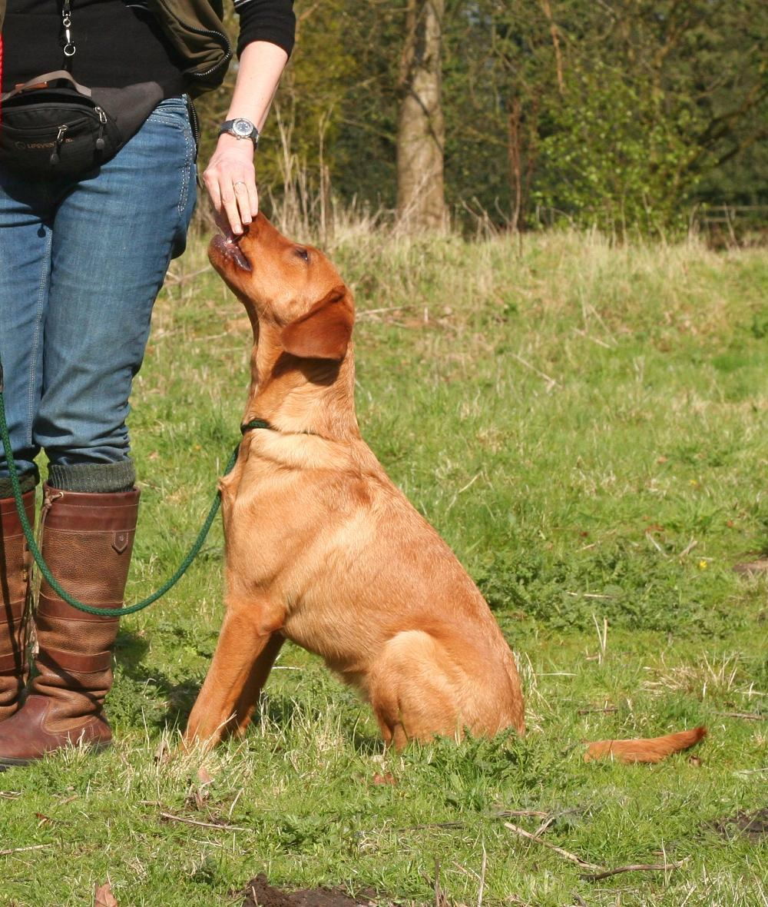
- Use a hand signal (e.g. flat hand) and say ‘wait’
- After 1 second, call your dog (using their recall word) across your body to the hand furthest away from your dog, and reward
- Repeat steps 2-3 until consistent
- When consistent every-time, give the ‘wait’ signals, and step 1 foot away from your dog
- Call them to you and reward
- Repeat and practice gradually increasing the distance you step away from them.

